2000 Team 358 Titans
Rookie Year

Robot Capabilities:
- Simple Back-n-Forth dump truck design
- Human Player loaded at top of Player station wall
- Hangs by hooks on dump truck

Physical Details:
- Dump Truck design
- Scissor jack telescoping for ball loading/dumping and hanging
- Hooks on hanging bar

Additional Info:
- #2 seed at SBPLI regional
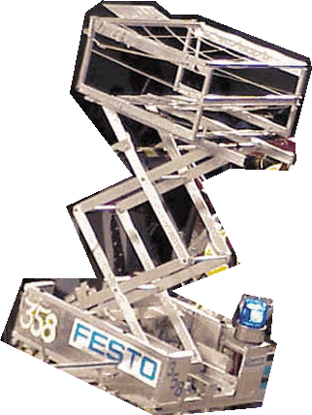
- Motorola Quality Award - SBPLI Regional

